**Types of**[**Recursions**](https://www.geeksforgeeks.org/recursion/)**:** **direct recursion** and another one is called **indirect recursion**.

**1.Direct Recursion**: These can be further categorized into **four types**:

* **Tail Recursion**: If a recursive function calling itself and that recursive call is the last statement in the function then it’s known as **Tail Recursion.**After that call the recursive function performs nothing. The function has to process or perform any operation at the time of calling and it does nothing at returning time.
* **Head Recursion**: If a recursive function calling itself and that recursive call is the first statement in the function then it’s known as **Head Recursion.**There’s no statement, no operation before the call. The function doesn’t have to process or perform any operation at the time of calling and all operations are done at returning time.
* **Tree Recursion**: To understand **Tree Recursion** let’s first understand **Linear Recursion**. If a recursive function calling itself for one time then it’s known as **Linear Recursion**. Otherwise if a recursive function calling itself for more than one time then it’s known as **Tree Recursion**.
* **Nested Recursion**: In this recursion, a recursive function will pass the parameter as a recursive call.That means **“recursion inside recursion”.**

2. I**ndirect Recursion**: In this recursion, there may be more than one functions and they are calling one another in a circular manner.

[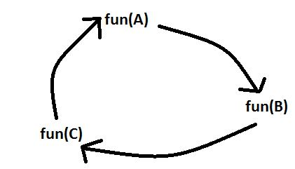](https://media.geeksforgeeks.org/wp-content/uploads/20190608232223/Capture34.jpg)